**Release Management Plan Document**

**for**

***MSM – EDW Implementation***

..........

**Document Revisions**

|  |  |  |  |
| --- | --- | --- | --- |
| **Date** | **Version** | **Description** | **Author** |
| 01-OCT-2015 | 0.1 | Initial Draft | Prateek Khare / Siva Nakshatrala |
|  |  |  |  |

**Note:** This document is strictly for Virtusa/Client use only. They shall not be shared with an external party other than the client concerned. This document should always be kept securely and employees shall use reasonable care protecting the documents from unauthorized use or disclosure to a third party. This also covers client intellectual property where Virtusa has a non-disclosure agreement with the client.

**Document Approval**

The following team members have reviewed this document and agree that the contents herein are accurate. Any changes to this document must be communicated to all parties for agreement.

|  |  |
| --- | --- |
| **Program Manager** | **Satish Goteti**  **<Sign Here>** |
| **Project Manager** | **Ashok Rayapeddi**  **<Sign Here>** |
| **Release Manager** | **Siva Nakshatrala**  **<Sign Here>** |

Contents

1. Introduction 4

2. Target Audience 4

3. Prerequisites for Release 4

4. Build Process 4

4.1 Release Naming Convention 4

4.2 Packaging and Release Procedure 5

4.3 Web Release Procedure 8

5. Release Process Overview 8

5.1 Emergency Release 8

5.2 Expedited Release 8

5.3 Reconciliation 8

5.4 Signoff 9

6. Contingency Plan 9

7. Personnel Requirements & Contact List 9

7.1 Resource List 9

7.2 Escalation List 9

8. Acronyms 10

# Introduction

The purpose of the Release Management Plan is to provide details and clarity on the steps involved in the implementation and rollout of the *MSM EDW Implementation* application packages. This also includes information to ensure that the implementation is conducted systematically in order to implement the enhancements and/or changes made to the application. This plan identifies critical activities required to ensure that the source code that has been developed and tested is successfully migrated from the SIT / User Acceptance Test (UAT) Environment to the Production Environment.

# Target Audience

The intended audience for the Release Management Plan is:

* Release Manager
* Project Manager
* Development Team
* Infrastructure Team

# Prerequisites for Release

* Acceptance Testing is complete and is signed off by the Change Management Coordinator / Lead.
* The downstream/upstream systems are notified about the production release.
* The rollout package is verified and tested by the development team prior to the production rollout.
* There are no unresolved outstanding issues reported during the UAT.
* There are no pending project issues pertaining to the release.

# Build Process

## 4.1 Release Naming Convention

**Dev / QA** – Code is deployed into branches and once it is live, the branch is merged into Trunk. Any new changes will be done a new branch.

**SIT/ UAT / PROD** - All the Talend code is deployed into Trunk and all DDLs are deployed into DB.

## 4.2 Packaging and Release Procedure

|  |  |  |  |
| --- | --- | --- | --- |
| Development Environment setup | | | |
| 1 | Setup the Project in Dev. | Release Manager | 2 days before start of construction |
| 2 | Verify that the project is created | Release Manager |
| 3 | Project is linked to common projects | Release Manager |
| 4 | Give Access to users | Release Manager |
| 5 | Construction - DDL is deployed as per the Cards. - Job schedule is constructed as part of the development. | Development Team |  |

|  |  |  |  |
| --- | --- | --- | --- |
| QA Test Environment Setup | | | |
| 1 | Project is created in QA environment | Release Manager | 2 days before start of testing |
| 2 | Project is linked to common projects | Release Manager |
| 3 | Ensure that the Configuration file for task creation is ready. | Release Manager | 1 day before start of testing |
| 4 | Ensure that the configuration file is uploaded into GitHUB Library | Release Manager |
| 5 | Ensure that the job scheduler chain is setup in QA.  Working Practice - For QA, team might use standalone jobs in TEST environment, but for further environments the job chain has to be setup. Ideally the design of the job chain also should be done during the design phase of the release itself. | Release Manager | During testing |
| 6 | Ensure that the DDL is ready to be deployed into QA and also is in sync with DEV DB. | Release Manager | 1 day before start of testing |
| 7 | Deploy the Talend Jobs using the new automated Pipeline. | Release Manager |  |
|  | Deploy the DDL and DML Changes | Release Manager |  |
|  | Deploy the Job Scheduler objects | Release Manager |  |
| 8 | QA Testing  - Individual cards  - Job Chain Testing | QA Team |  |

|  |  |  |  |
| --- | --- | --- | --- |
| SIT & UAT Test Environment Setup | | | |
| 1 | Project is created in SIT & UAT environment | Release Manager | 2 days before start of testing |
| 2 | Project is linked to common projects | Release Manager |
| 3 | Ensure that the Configuration file for task creation is ready. | Release Manager | 1 day before start of testing |
| 4 | ~~Ensure that the Configuration file is uploaded into GitHUB Library~~ - Not applicable for SIT | Release Manager |
| 5 | Ensure that the job scheduler chain is setup in SIT. | Release Manager | During testing |
| 6 | Ensure that the DDL is ready to be deployed into SIT and also is in sync with DEV DB. | Release Manager | 1 day before start of testing |
| 7 | Deploy the Talend Jobs using the new automated pipeline | Release Manager |  |
|  | Deploy the DDL and DML Changes | Release Manager |  |
|  | Deploy the Job Scheduler objects | Release Manager |  |
| 8 | SIT Testing  - Job Chain Testing | SIT Test Team |  |

|  |  |  |  |
| --- | --- | --- | --- |
| LIVE Deployments | | | |
| 1 | Project is created in Live environment | Release Manager | 2 days before start of testing |
| 2 | Project is linked to common projects | Release Manager |
| 3 | Ensure that the Configuration file for task creation is ready. | Release Manager | 1 day before start of testing |
| 5 | Ensure that the job scheduler chain is setup in Production. | Release Manager | During testing |
| 6 | Ensure that the DDL is ready to be deployed into Production and also is in sync with DEV DB. | Release Manager | 1 day before start of testing |
| 7 | Deploy the Talend Jobs using the new automated pipeline | Release Manager |  |
|  | Deploy the DDL and DML Changes | Release Manager |  |
|  | Deploy the Job Scheduler objects | Release Manager |  |
|  | Deploy the required configuration files / Script files | Release Manager |  |
| 8 | Live Testing  - Job Chain Testing |  |  |

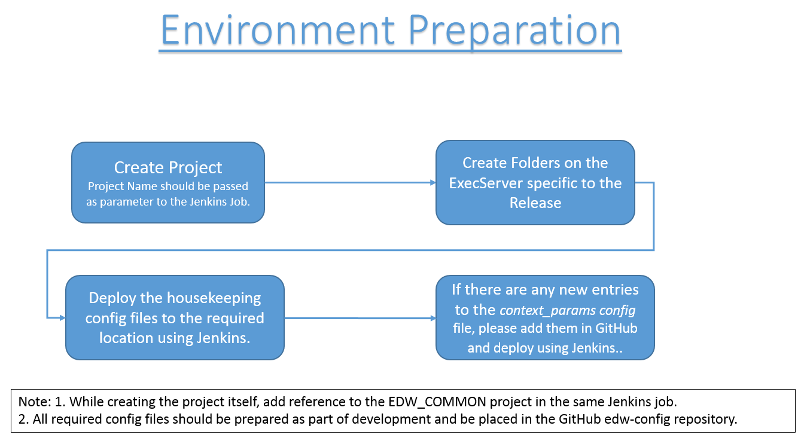

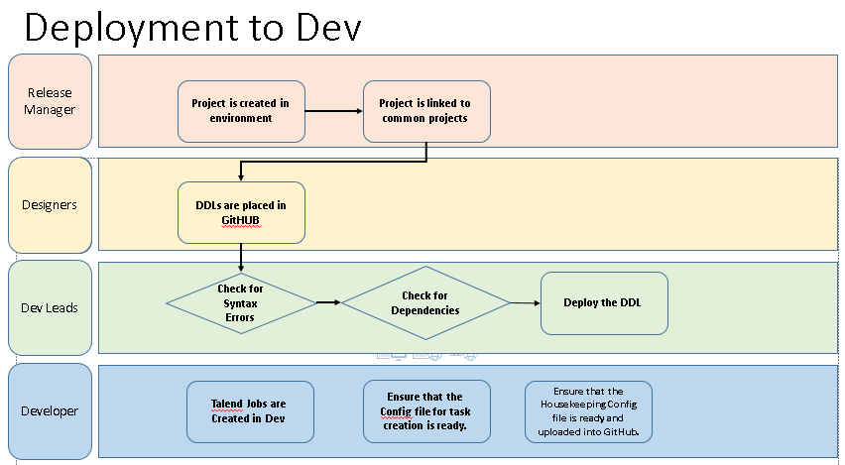

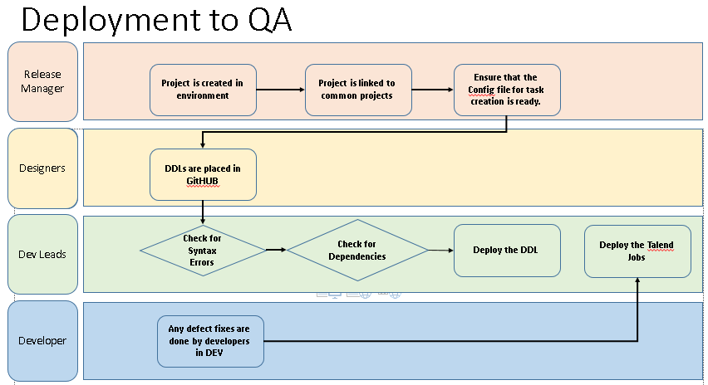

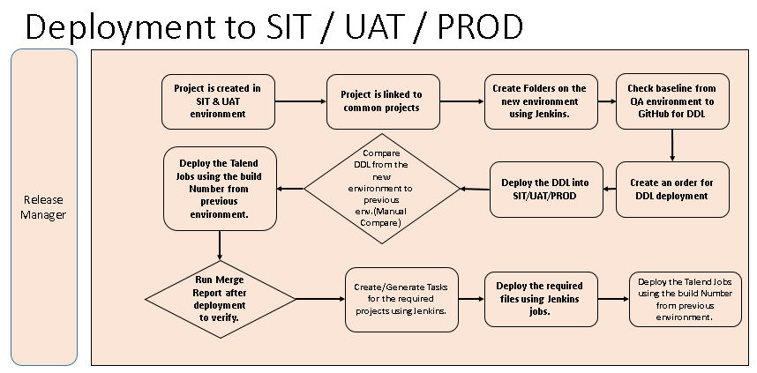

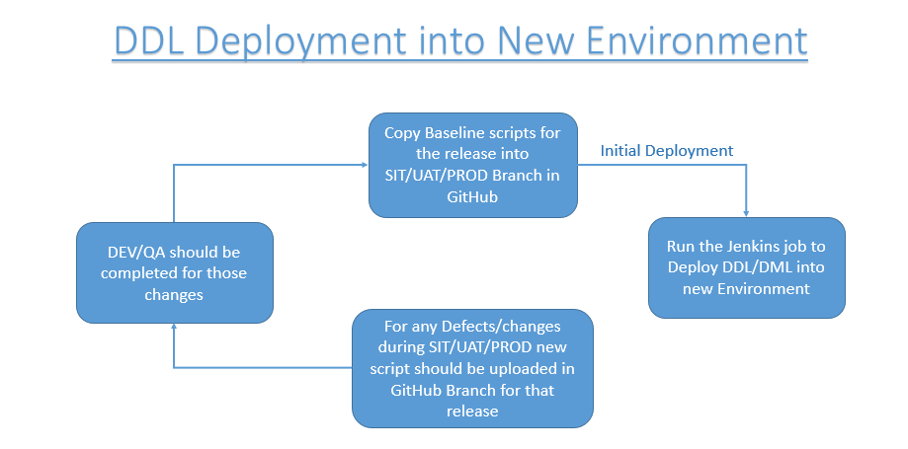

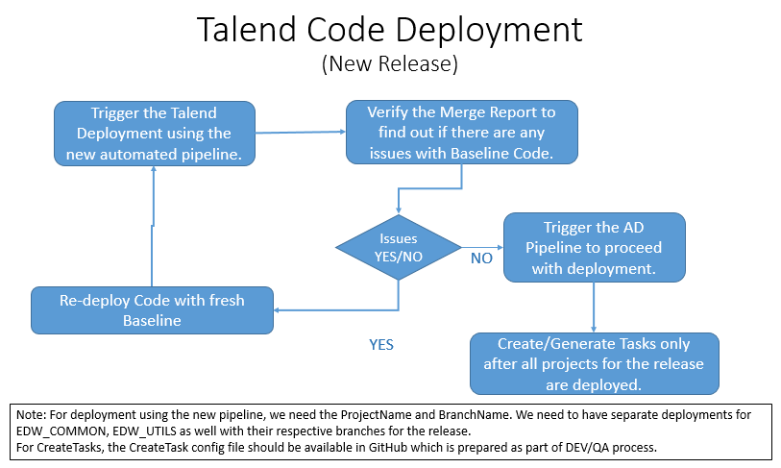

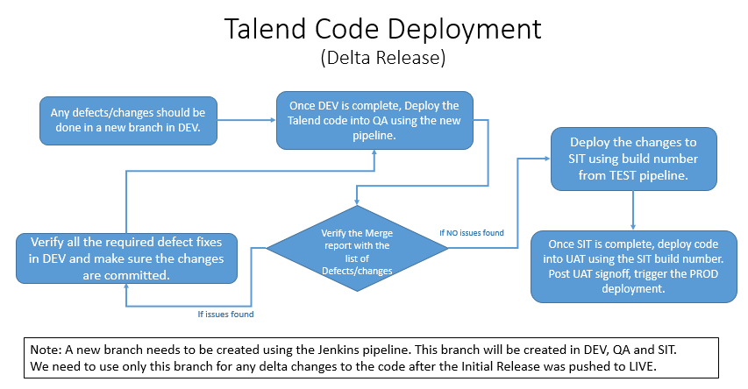

## 

## 4.3 Web Release Procedure

1. Not Applicable

# Release Process Overview

Detailed in Section 4.2

## 5.1 Emergency Release

TBD

## 5.2 Expedited Release

TBD

## 5.3 Reconciliation

TBD

|  |  |  |  |
| --- | --- | --- | --- |
| **TASK** | **DATE** | **RESPONSIBILITY** | **REMARKS** |
| Inform deployment team about the release and location of the packages to be deployed | Two week s before the release | Technical Lead | Send email to *<Group Name>* group |
| Prepare Release Notes | Before start of UAT | Lead Developers | Release Notes will contain specifics to the intended release. |
| Send Release Notes to the Deployment team | One day before release | Technical Lead | Send email to *<Group Name>* group |
| FTP web packages to the production server | One day before release | Web Lead Developer | https://.. |
| Backup the databases | Day of release | Lead Developer | For restore/rollback purposes |

## 5.4 Signoff

TBD

# Contingency Plan

TBD

# Personnel Requirements & Contact List

## 7.1 Resource List

|  |  |  |  |  |
| --- | --- | --- | --- | --- |
| **ROLE** | **NAME** | **PHONE** | | **EMAIL** |
| Lead Developer | Shirisha Beeravolu  Narasimha Rao Boinapalli  Srinivasa Chaitanya |  | <shirishab@virtusa.com>;  <rbnarasimha@virtusa.com>;  <srinivasacs@virtusa.com> | |
| Deployment Lead | Sivakumar Nakshatrala | | <nsivakumar@virtusa.com> | |
| Infrastructure Support | JayaRam Suryadevara |  | <jayarams@virtusa.com> | |

## 7.2 Escalation List

|  |  |  |  |
| --- | --- | --- | --- |
| **ROLE** | **NAME** | **PHONE** | **EMAIL** |
| Technical Lead | Andy Burnage Chandu RH |  | <aburnage@virtusa.com>;  <hukumchandur@virtusa.com> |
| Change Management Lead | Satish Goteti Ashok Rayapeddi |  | <satishkg@virtusa.com>;  <arayapeddi@virtusa.com> |
| Change Management Chief |  |  |  |

# Acronyms

|  |  |
| --- | --- |
|  |  |
|  |  |